THE SWITCH FUNCTION()
- USE of the SWITCTH Function to show program figures in bands.
Open the Power BI Desktop file in the above folder to see:


- In the underlying table, create a new column called Viewing Band which uses the SWITCH function to allocate series to different bands according to these rules:
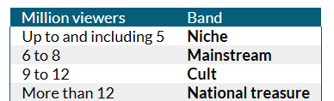
NOTE: The syntax of the SWITCH function is usually:
=SWITCH ( TRUE(), First condition, what if it's true, ... , Last condition, what if it's true, What to do if none of the conditions was true )
- Turn the report's table into a matrix and use it to count how many series there were in each band for each channel:
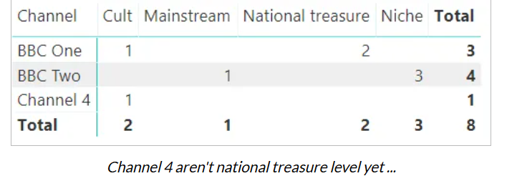

- Save this file as There was only one Rahul, then close it down.

